Noah Franck

8/28/18

iOS Project

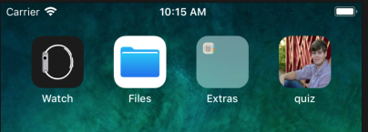

CODE

let answers: [String] = ["14","Brussels","Buster the Bulldog"]

var currentQuestionIndex: Int = 0

@IBAction func showNextQuestion(_sender:UIButton)

{

if currentQuestionIndex < questions.count - 1

{

currentQuestionIndex += 1

}

else if currentQuestionIndex == questions.count - 1

{

currentQuestionIndex = 0

}

questionLabel.text = String(currentQuestionIndex + 1) + ": " + questions[currentQuestionIndex]

answerLabel.text = ""

}

@IBAction func showAnswer(_sender:UIButton)

{

answerLabel.text = answers[currentQuestionIndex]

}

override func viewDidLoad()

{

super.viewDidLoad()

questionLabel.text = String(currentQuestionIndex + 1) + ": " + questions[currentQuestionIndex]

answerLabel.text = ""

}

